**INSTALLATION AND USER INSTRUCTIONS**

**QUIZCRAFT**

**A QUIZ PLATFORM**



February 2025  
Version 1.00

**DISCLAIMER**

The information provided in this document is for general informational and educational purposes only. QuizCraft makes no representations or warranties of any kind, express or implied, about the completeness, accuracy, reliability, suitability, or availability of the information contained herein. Any reliance placed on such information is strictly at the reader’s own risk.

The content is provided “as is” without any guarantees of completeness, accuracy, or timeliness. QuizCraft shall not be liable for any loss or damage, including but not limited to indirect or consequential loss or damage, arising from the use of this content.

All rights, including copyrights and trademarks, are owned by QuizCraft. Unauthorized reproduction, distribution, or modification of this material, in whole or in part, is strictly prohibited without prior written consent.

For further inquiries or permissions, please contact:

QuizCraft

Admin Details

**Table of Contents**

1. **Preface……………………………………………………………………………4**
   * 1.1 Description of the User………………………………………………………………………………4
   * 1.2 Conventions Used in This Manual………………………………………………………………4
   * 1.3 Explanation of Safety Warnings………………………………………………………………….5
   * 1.4 Retaining Instructions………………………………………………………………………………..5
   * 1.5 Obtaining Documentation and Information……………………………………………….6
     + 1.5.1 Internet………………………………………………………………………………………6
     + 1.5.2 Ordering Documentation……………………………………………………………6
     + 1.5.3 Documentation Feedback…………………………………………………………..6
2. **Description of the Product………………………………………………………8**
   * 2.1 Purpose of the Product………………………………………………………………………………8
   * 2.2 Technical Data……………………………………………………………………………………………8
   * 2.3 Product Compliance…………………………………………………………………………………..8
   * 2.4 Product Elements………………………………………………………………………………………9
   * 2.5 Understanding the User Interface……………………………………………………………..11
   * 2.6 Operating Panels……………………………………………………………………………………….12
3. **Safety Instructions……………………………………………………………...13**
   * 3.1 How to Use the Product Safely………………………………………………………………….13
     + 3.1.1 Safety Information for Vulnerable People…………………………………..13
     + 3.1.2 Personal Safety…………………………………………………………………………..13
     + 3.1.3 Work Area Safety…………………………………………………………………..…..13
     + 3.1.4 Data Safety…………………………………………………………………………………13
4. **Preparation……………………………………………………………………...14**
   * 4.1 How to Transport and Store Quiz Data………………………………………………………14
     + 4.1.1 Secure Handling and Transmission of Quiz Data…………………………14
     + 4.1.2 Storing Quiz Data……………………………………………………………………….14
   * 4.2 How to Install the Quiz Application……………………………………………………………15
     + 4.2.1 Setting Up the Application and Removing Installation Barriers…..15
     + 4.2.2 Initializing the Quiz System…………………………………………………………15
5. **Conducting the Quiz…………………………………………………………....16**
   * 5.1 How to Use the Quiz System……………………………………………………………………..16
     + 5.1.1 Quiz Environment Requirements……………………………………………….16
     + 5.1.2 Conducting a Manual Quiz…………………………………………………………16
     + 5.1.3 Local/Remote Quiz Hosting……………………………………………………….16
     + 5.1.4 Manual/Automated Quiz Execution…………………………………………..16
     + 5.1.5 Starting/Stopping a Quiz……………………………………………………………17
     + 5.1.6 Pre-Quiz Checks………………………………………………………………………..17
6. **What to Do in Emergency and Exceptional Situations………………………18**
   * 6.1 Emergency Situations……………………………………………………………………………18
   * 6.2 Exceptional Situations……………………………………………………………………………18

# PREFACE

## Description of the user

The **QuizCraft** platform is designed for a wide range of users who wish to create, manage, and participate in quizzes. The intended users include:

* **Students**: Individuals who want to test their knowledge and practice for exams through interactive quizzes.
* **Teachers/Instructors**: Users who create quizzes, assign them to students, and analyze their performance.
* **Quiz Enthusiasts**: Individuals who enjoy participating in quizzes for fun or competitive purposes.
* **Administrators**: Personnel responsible for managing user accounts, quiz settings, and overall system configurations.

Users are expected to have a **basic understanding of computers and the internet** to navigate and operate QuizCraft efficiently.

## Conventions used in this manual

This manual follows standard documentation conventions:

* **Bold** text is used for **menu options, buttons, and UI elements** (e.g., **Start Quiz**, **Submit Answer**).
* *Italic* text is used to indicate **important notes, variables, and emphasized terms** (e.g., *Ensure you save changes before exiting*).
* Code-like text is used for **commands or input fields** (e.g., quiz_id=12345).
* Numbered lists indicate **step-by-step processes**, and bullet points are used for general guidelines.

## Explanation of safety warnings

To ensure a **secure and seamless experience**, users must adhere to the following safety guidelines:

1. Always **use strong passwords** to protect your account.
2. Never **share login credentials** with others.
3. Ensure **browser and system security updates** are installed.
4. **Log out** after using the system, especially on shared or public computers.
5. Avoid accessing QuizCraft through **unsecured or public Wi-Fi networks** to prevent unauthorized access.

## Retaining instructions

Read and understand this manual and its safety instructions before using this product. Failure to do so can result in serious injury or death.

Follow all the instructions. This will avoid fire, explosions, electric shocks or other hazards that may result in damage to property and/or severe or fatal injuries.

Keep all safety information and instructions for future reference and pass them on to subsequent users of the product.

## Obtaining documentation and information

### Internet

Visit the official QuizCraft website for updates, FAQs, and additional resources.

### Ordering documentation

Printed copies of this manual can be requested through customer support.

### Documentation feedback

Users can send feedback or request additional help through [support email/website].

We appreciate your comments.

# Description of the product

## Purpose of the product

QuizCraft is a **versatile quiz management system** that allows users to:

* Create **custom quizzes** with different types of questions.
* Manage quizzes with **time limits, difficulty levels, and scoring rules**.
* Track **performance analytics and progress reports**.

## Technical data

• Compatible with **Windows, macOS, and Linux**.

• Supports various quiz formats: **Multiple Choice, True/False, Short Answer, and Fill in the Blanks**.

• Uses **secure encryption** to protect user data.

## Product Compliance

## QuizCraft follows **industry standards** for accessibility and data security, ensuring compliance with **GDPR** and **ISO security protocols**.

## Product elements

• **User Dashboard**: Personalized dashboard showing quizzes, scores, and achievements.

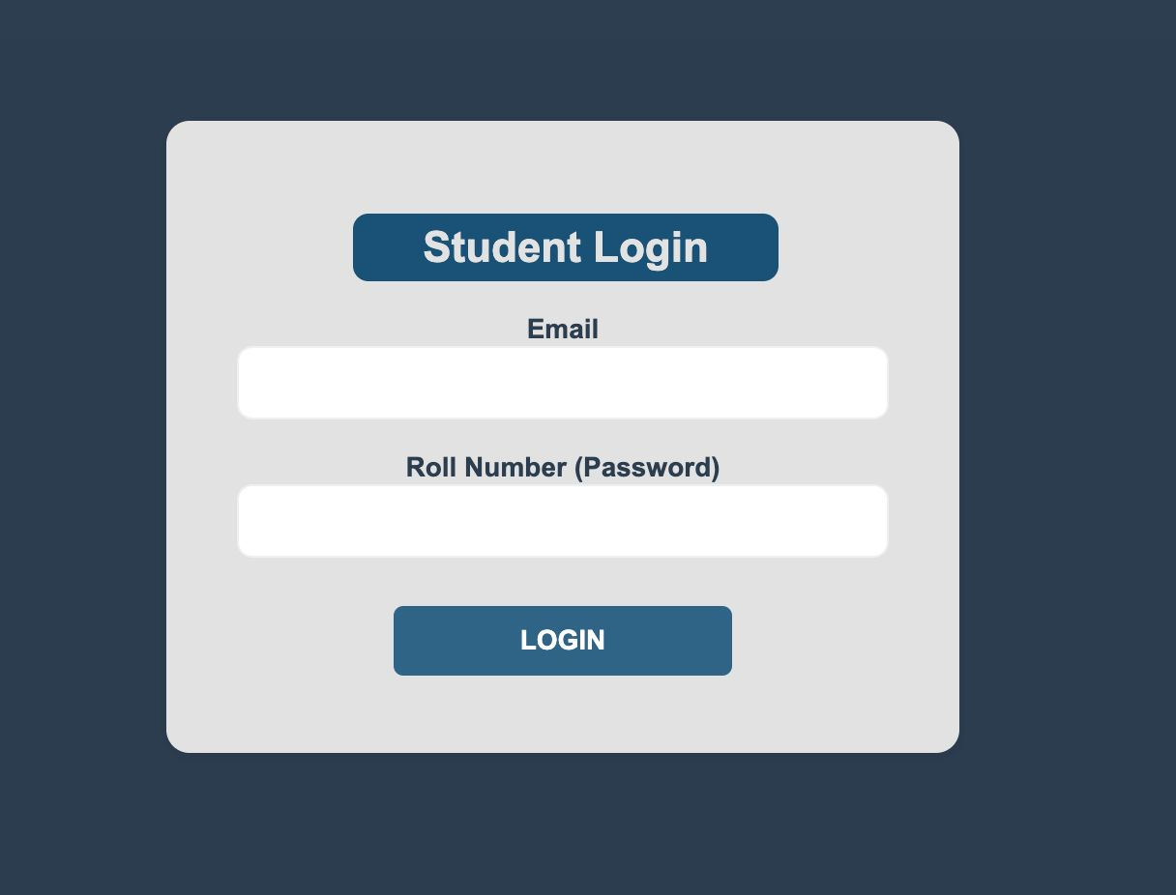

• **Quiz Creator**: Tool for teachers/admins to design quizzes.

• **Admin Panel**: Used to manage users, configure settings, and generate reports.

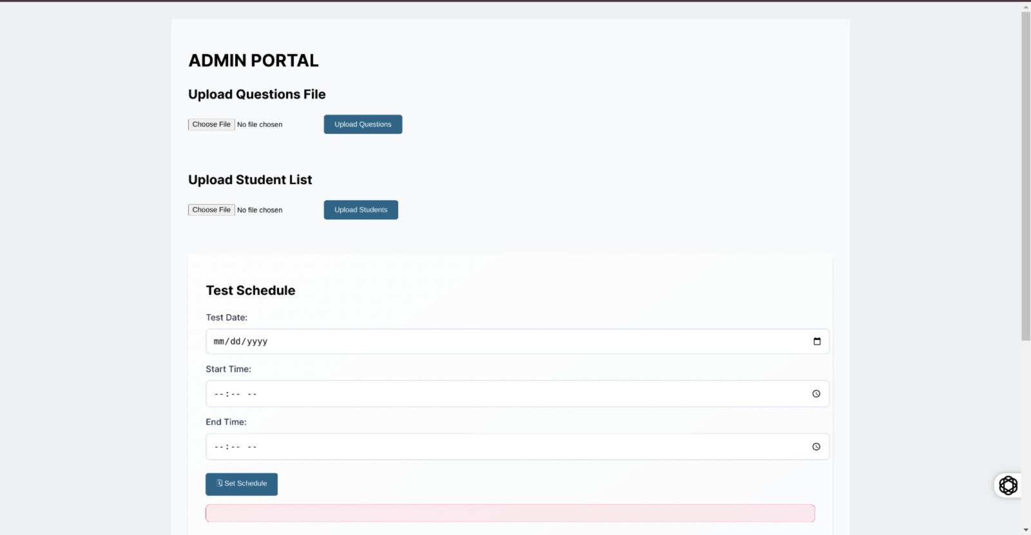

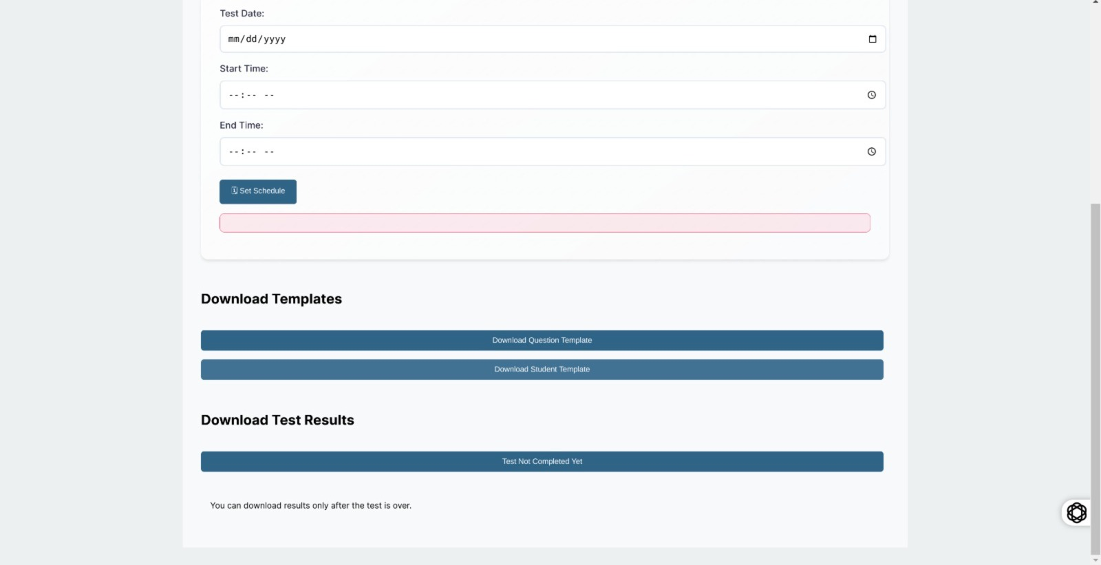

## Understanding the user interface

The interface includes:.

1. **Quiz Panel** – Where users take quizzes.

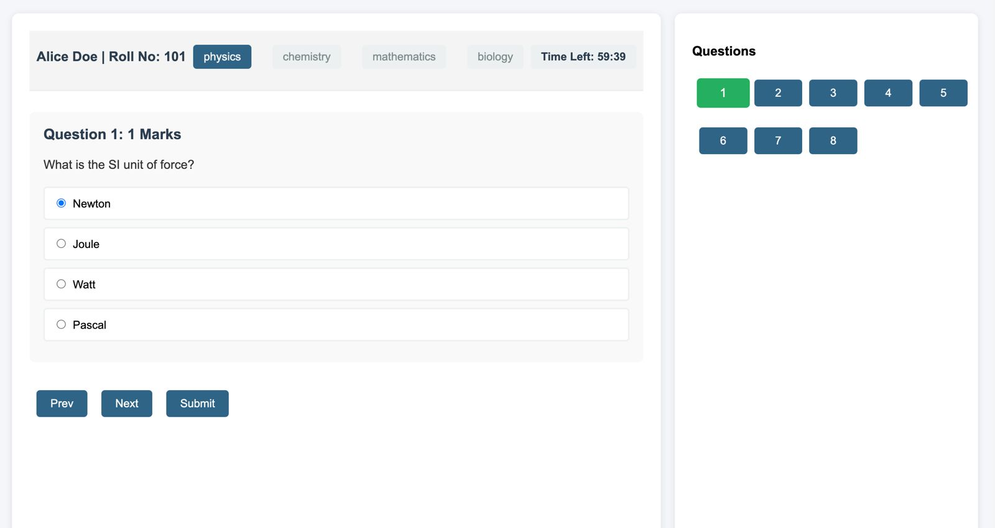

1. **Results Section** – Displays scores and correct answers.

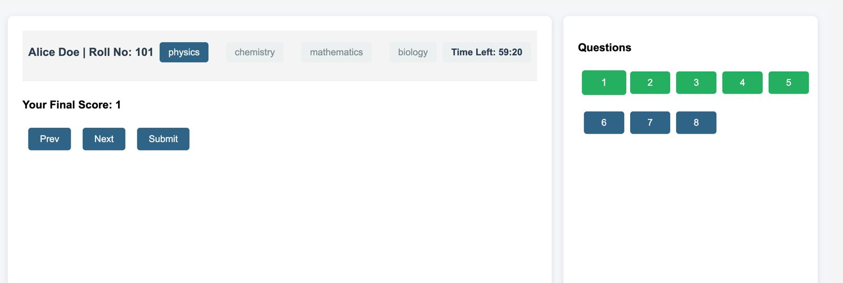

1. **Instructions Page –** Gives the quiz description along with important instructions.

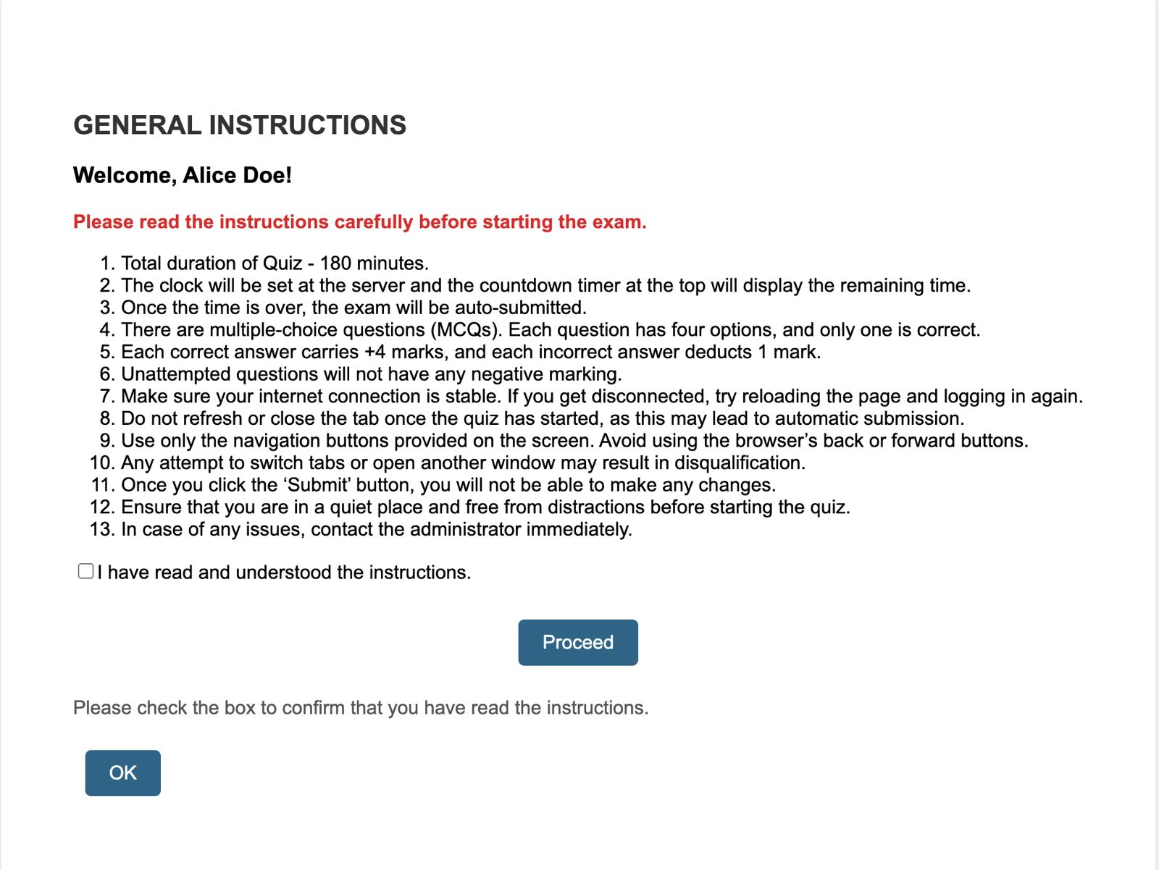

## Operating panels

• **Student Panel**: For taking quizzes and viewing scores.

• **Admin Panel**: For managing users and system settings.

# Safety instructions

**WARNING!** To ensure a secure and fair quiz experience, follow all guidelines strictly. Violating security measures may result in account suspension or disqualification.  
**Example:** **WARNING! Unauthorized access detected.** Multiple failed login attempts or suspicious activity may lead to a temporary lockout. Ensure secure login credentials and avoid sharing your account details.

### ****3.1 How to use the product safely****

#### ****3.1.1 Safety information for vulnerable people****

* **Ensure secure login credentials** to prevent unauthorized access.
* **Avoid sharing personal information** with others on the platform.

#### ****3.1.2 Personal safety****

* **Log out** after using the application on shared or public devices.
* **Enable two-factor authentication (2FA)** for additional security.

#### ****3.1.3 Work area safety****

* **Use a stable internet connection** to prevent data loss during quizzes.
* **Avoid using the application on unsafe public Wi-Fi networks.**

#### ****3.1.4 Data safety****

* **Regularly update your password** to enhance account security.
* **Backup quiz data** to prevent accidental loss.

# Preparation

### ****4.1 How to transport and store quiz data****

#### ****4.1.1 Secure handling and transmission of quiz data****

To securely transmit quiz data:

1. Encrypt all quiz data before transmission.
2. Use secure channels such as HTTPS or VPNs.
3. Ensure only authorized personnel have access to sensitive data.

To safely handle quiz data:

1. Implement role-based access controls.
2. Regularly update security patches.
3. Monitor access logs for suspicious activity.

To securely store quiz data:

1. Store quiz questions and responses in an encrypted database.
2. Implement backups with access restrictions.
3. Regularly review and update security protocols.

#### ****4.1.2 Storing quiz data****

To maintain the integrity of stored quiz data:

1. Restrict access to quiz results and sensitive information.

### ****4.2 How to install the quiz application****

#### ****4.2.1 Setting up the application and removing installation barriers****.

To properly install the quiz application:

1. Download the latest version from a trusted source.
2. Run the setup with administrator privileges.
3. Follow on-screen instructions for configuration.

#### ****4.2.2 Initializing the quiz system****

To start the quiz system:

1. Configure the database and set up user authentication.
2. Customize quiz settings according to the institution’s requirements.
3. Run a test quiz to verify system functionality.

## ****5. Conducting the Quiz****

### ****5.1 How to use the quiz system****

#### ****5.1.1 Quiz Environment Requirements****

To ensure a smooth quiz experience:

1. Ensure a stable internet connection.
2. Use a compatible browser or application version.
3. Verify participant access credentials in advance.

#### ****5.1.2 Conducting a Manual Quiz****

Steps to conduct a quiz manually:

1. Select the quiz from the dashboard.
2. Assign participants and set time limits.
3. Start the quiz and monitor progress.

#### ****5.1.3 Local Quiz Hosting****

To host a quiz locally:

1. Set up a controlled environment.
2. Ensure all devices are connected to the same network.
3. Start the quiz and distribute credentials.

#### ****5.1.4 Manual/Automated Quiz Execution****

For manual execution:

1. Start and stop the quiz manually.
2. Review and grade responses after completion.

For automated execution:

1. Set predefined start and end times.
2. Enable automatic grading and result generation.

#### ****5.1.5 Starting / Stopping a Quiz****

To start a quiz:

1. Select the quiz and verify settings.
2. Click ‘Start Quiz’.
3. Monitor progress.

To stop a quiz:

1. Click ‘End Quiz’.
2. Review participant responses.
3. Save and export results.

#### ****5.1.6 Pre-Quiz Checks****

Before starting a quiz:

* Verify participant access.
* Check system compatibility.
* Ensure backup options for technical issues.

#### ****6. What to Do in Emergency and Exceptional Situations****

##### **6.1 Emergency Situations**

In case of an emergency situation:

1. Follow the designated emergency protocol.
2. Notify the appropriate authorities or support team.
3. Take immediate corrective actions to mitigate the issue.

##### **6.2 Exceptional Situations**

In case of an exceptional situation:

1. Identify the cause of the issue.
2. Apply the recommended troubleshooting steps.
3. Escalate to technical support if necessary.